NOTE: You should already have created your C++ Actor class “UdpReceiverActor” using Visual Studio 2022 in Part 1.

This document explains two options for creating Blueprint (BP_) actors in UE5 that either (1) directly listen to a UDP port using UdpReceiverActor, or (2) act based on UDP data exposed by a shared UdpReceiverActor instance.
- In Unreal Engine 5, only one actor can listen on a given UDP port.
- Because of this, both options use a single listener. The difference is how many other actors use the data.
- Option 1: A single, self-contained Blueprint actor both listens on the UDP port and acts on the data itself. No other actors are involved.
- Option 2: One Blueprint actor listens on the UDP port, and additional Blueprint actors reference it to access and act on the same UDP data.

OPTION 1 — A Single Blueprint of UdpReceiverActor
3 Key Points
- One Blueprint inherits from UdpReceiverActor and handles both listening and display logic.
- No reference variables needed.
- Only one such actor should exist in the level.

HOW TO EXECUTE OPTION 1

STEP 1 — Create the Blueprint That Is the Listener

- In the Content Browser (control space), click “Add (+)” → “Blueprint Class”.
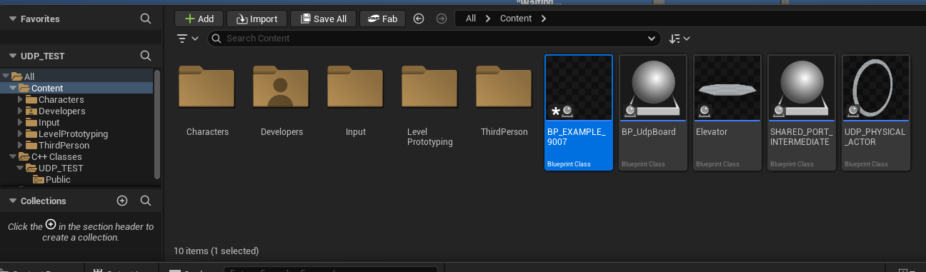
- Select “All Classes”.
- Search for “UdpReceiverActor”.
- Choose it and name it as BP_Name_9000
Replace name with desired name… and replace 9000 with desired port.

STEP 2 — Add Components and Logic

- Double click on your blueprint in the content browser to open the blueprint editor.

- In the details panel, set your listen port in UDP Settings ex 9000
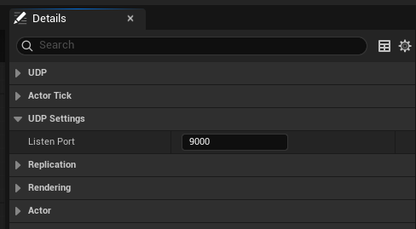
- In the ViewPort: Design what your actor looks like…Click the (+Add) component in the top right to add a TextRender, Mesh, or any other display component.
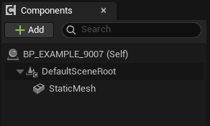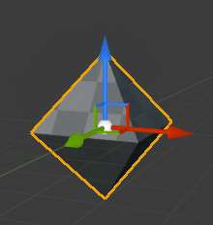

- Construction Script: leave empty

- Event Graph: this is the logic page. You must use “LastMessage” (which is an inherited variable from the c++ class that looks at the last received input from UDP). An event tick is like your clock cycle. See example below that converts the UDP input to a float, scales it 0-360 and rotates the object and the Y axis based.
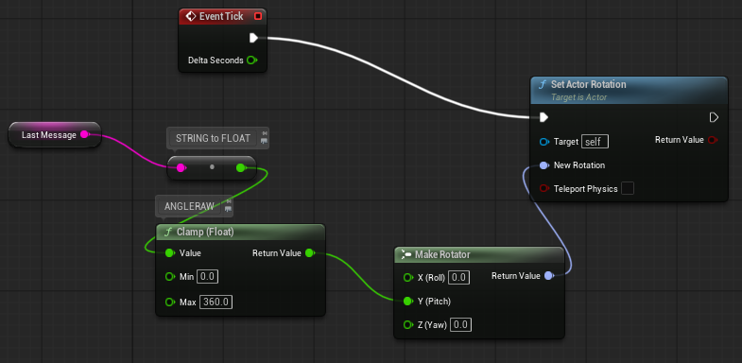
- Compile

STEP 3 — Place Only One in the Level
- Close Blueprint editor and drag your BP_Name_9000 into the level (main UE5 page)
- In the Details panel, confirm the port.
- Do not place any additional UdpReceiverActor-based actors with the same port.
- Turn on the data stream to that port and click run.

OPTION 2 — One Shared UdpReceiverActor + Many Normal Actors Referencing It
3 Key Points
- Create one Blueprint based on your UdpReceiverActor C++ class and place it in the level.
- Create normal Actor Blueprints that reference the shared listener (they should NOT inherit from UdpReceiverActor).
- The reference variable must be Editable so you can assign the shared listener in Class Defaults.

HOW TO EXECUTE OPTION 2

STEP 1 — Create + Place the Shared UDP Listener
A. Create the Blueprint Class
- Open the Content Browser.
- Click “Add (+)” → “Blueprint Class”.
- Select “All Classes” on the left.
- Search: “UdpReceiverActor”.
- Select it and name the new Blueprint: Shared_Port_Intermediate.
B. Set the Listening Port
- Shared_Port_Intermediate
- Click “Class Defaults”.
- In the Details panel, search for “ListenPort”.
- Set it to the desired port (e.g., 9000).
C. Place It in the Level
- Return to the main viewport.
- Drag Shared_Port_Intermediate from the Content Browser into the level.
- Select it and confirm in Details that ListenPort is correctly set.
This actor is the only one actually listening to the UDP port.

STEP 2 — Create a Normal Actor That Uses the Data (NOT a child of UdpReceiverActor)
A. Create a New Actor Blueprint
- In the Content Browser, click “Add (+)” → “Blueprint Class”.
- Select “Actor”.
- Name it BP_DisplayActor (or anything you want).
B. Add Components (Optional UI)
- DoubleClick BP_DisplayActor.
- In the Viewport tab, click “Add Component”.
- Add a TextRender (optional for testing).
C. Create an Editable Reference Variable
- In the “My Blueprint” panel, click “+ Variable”.
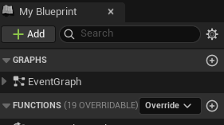
- Name the variable UdpRef.
- In the Details panel:
  - Change Variable Type to Shared_Port_Intermediate→ Object Reference.
  - Check Instance Editable !!!!!!!!!!!!
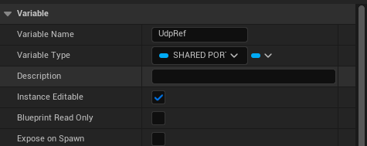
  - Do NOT make this actor inherit from UdpReceiverActor.
D. Construction Script
- Leave empty.
E. Event Graph
- Right click search UdpRef then get UdpRef. Drag the blue line to the right. Then type Last message.
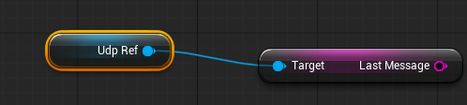
- Finish custom logic (see example) filtering may be necessary. 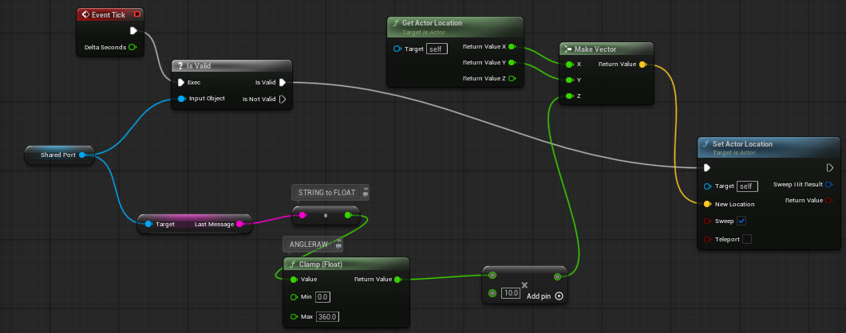

STEP 3 — Assign the Shared Listener Reference
Using Class Defaults
- Close blueprint editor
- Drag your BP_DisplayActor into the game.
- In the Details panel, under default.
- Assign drop down menu to Shared Port Intermediate
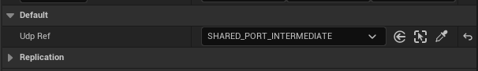
Now, every time you drag BP_DisplayActor into the level, its UdpRef is already correctly set.
Repeat step two to create additional actors that reference shared port intermediate…. if you didn’t need multiple then you should have done OPTION 1 : (

